**ACT/BAC1601; BAC1602; IBE1122: Fundamental of financial accounting**

Instructor: A. Issorasak Santivitoonvongs

อิศรศักดิ์ สันติวิฑูรวงศ์

**Tips in learning this course.**

* Pay attention especially for the first 3 chapters because it will create a strong basic knowledge for your best understanding.
* Practice the assignments.

We shall have two quizzes. 1st Quiz before midterm, and 2nd quiz before final. Dates will be informed later.

**MARKS ALLOCATION:**

* Quiz I and Quiz II (3% + 3%) 6%
* Attendance + Assignments 4%
* Mid-term exam 40%
* Final exam 50%

# **TOTAL 100%**

**What is Accounting?**

The definition of accounting given by AICPA (American Institute of Certified Public Accountant)

Accounting is the language of business. Accounting is also an information system because it contains Input, process and output.

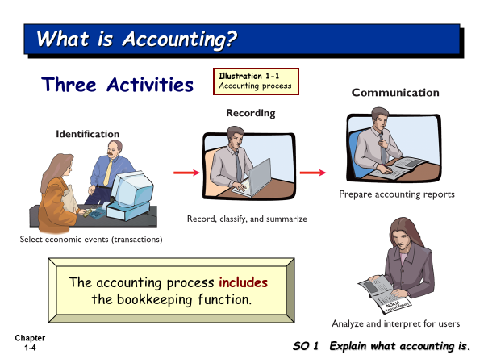

There are many events occurred every day. Some events are economic events, and other events are not. The accountant has to select the economic event for recording.

**What is the economic event (transaction)?**

It is the event which has impact on accounts in the **accounting equation**.

Identification is the most difficult activity. This activity is about how we can select the economic events from events. Then accountant will record the economic events in their books. Identification here is how to select and analyze the economic events.

The output of accounting is the **accounting reports** which will be submitted to the interested users of the accounting reports who want to use the accounting data.

**Accounting reports (Financial Statements) include**

1. Income Statement
2. Retained Earnings Statement
3. Statement of financial position
4. Cash Flow Statement
5. Note disclosure

**Who uses the accounting data?**

There are internal users and external users.

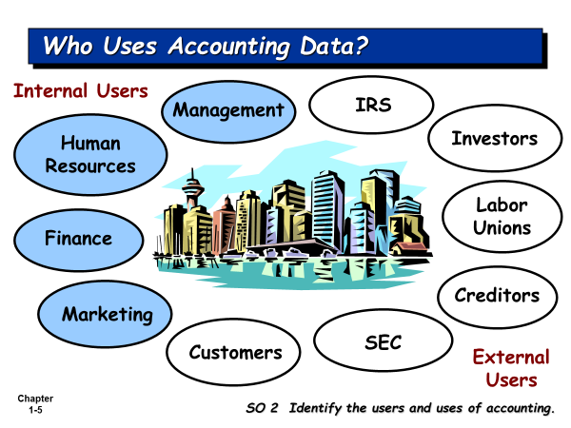

**IRS – Internet Revenue Service**

**SEC – Securities and Exchange Commission**

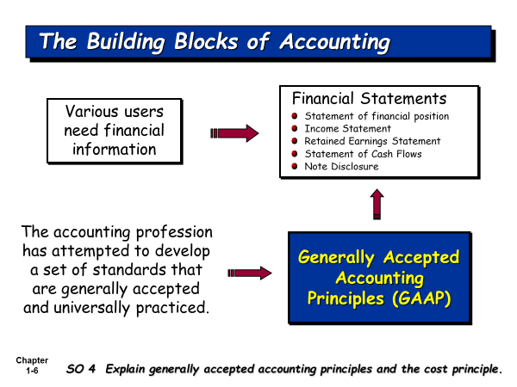

The financial statements must be prepared based on GAAP. Various users from various countries can read the reports and understand the same things from the reports. *GAAP was developed by the accounting profession (Accountant) in order to get a set of standards which are generally accepted and universally practiced.*

**What is GAAP?**

**Generally Accepted Accounting Principles (GAAP)** is the standard framework of guidelines for [financial accounting](http://en.wikipedia.org/wiki/Financial_accounting). It includes the standards, conventions, and rules that accountants follow in recording and summarizing transactions, and in the preparation of statements.

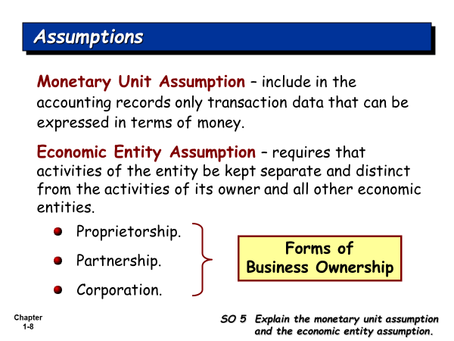

**Set up his company**

**Owner Organization (business firm)**

**Accountant** has to record the transactions for the business firm, not for the owner, because the accountant must hold the Economic Entity Assumption, that is, Owner and his business firm are the separate entity.

**Table 2.1 Some Accounting Concepts**

|  |  |
| --- | --- |
| **Basic Accounting Concepts** | **What It Means in Relationship to a Financial Statement** |
| **1. Separate Economic Entity Assumption** | Owner and his business firm are the separate entity. Shareholders are the separate entity from their company. |
| **2 Going Concern Assumption** | It is assumed that once the business firm is opened, the owner will run his business into the future quite long enough until he can meet his objectives. |
| **3. Monetary Unit Assumption** | An economic entity's accounting records include only quantifiable transactions. Accounting must be recorded using a stable currency e.g., the U.S. dollar, Thai Baht |
| **4. Time Period Assumption** | Most businesses exist for long periods of time (Going Concern Assumption). The accountant will artificially divide it into an equally time period, i.e., the company’s accounting period, which can be monthly, quarterly, and annually. We need to report the performance of our company under each accounting period. |
| **5. Historical Cost Principle** | **A**ssets are reported and presented at their original cost, e.g., our company bought equipment at 100,000 Baht, we record it at cost. |
| **6. Matching Principle (or Expense Recognition Principle)** | The matching principle requires that expenses incurred be matched with revenues generated from these expenses for an accounting period. |
| **7. Revenue Recognition Principle** | Revenue will be recognized (recorded) when our company’s service has been completed, or product has been delivered to customers, even money has not yet been collected. |
| **8. Full Disclosure Principle** | The full disclosure principle requires that financial statements include disclosure of information that is important to the users of the financial statements. It can be disclosed in the notes to the financial statement. |
| **9. Materiality** | Some expenses are very small, like taxi fare, stamps and so on, the accountant prefers to record them in one account, such as, Miscellaneous Expense. |
| **10. Conservatism Concept** | Under the uncertainty situation, the accountant will under-estimate the revenue and assets, and will over-estimate expenses and liabilities. |

1st act period (Jan 1- Dec 31)2nd act period (Jan 1, 2022 – Dec 31, 2022)

Jan 1, 2021 Dec 31,2021

I start my business on Jan 1, 2021. I want to run my business quite long enough until I can meet my objectives.

How can I measure the performance of my business firm? I want to know whether my business firm can make profit or not? We use the time period assumption in order to divide the life time of our business firm into an equal time period. We call it Accounting period. The companies in Thailand have accounting period of 1 year.

Net Income = Revenues – Expenses

How we recognize the revenue? We follow Revenue Recognition Principle.

How we recognize the expense? We follow Expense Recognition Principle (Matching).

**There are 3 forms of business ownership**

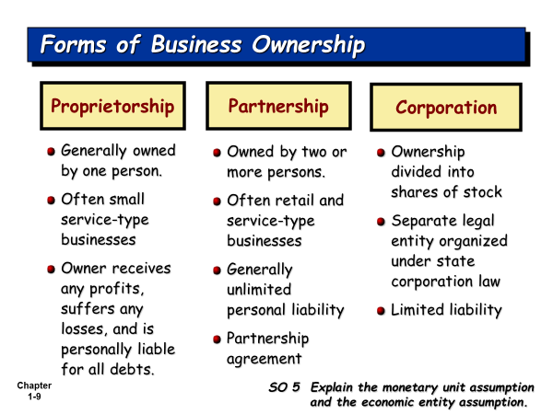

**Types of Business Operation**

1. **Service business**. The company sells the service (Complete/Provide/Rendered the service) to customers. Chapter 1 – 4 focuses recording business transactions for service business.
2. **Manufacturing business.** The company produces the products and sells the product to customers.
3. **Merchandising business**: The company buys the products, and then sells the product to customers. Chapter 5 focuses recording business transactions for merchandising business.

**Fields of Accounting**

1. **Financial Accounting:** The accounting reports will be presented to the internal and external users
2. **Managerial or Cost Accounting:** The managerial accounting reports will be used by the managers of all levels for their planning, directing, and controlling of their operations.
3. **Tax determination and planning**
4. **Public Accounting/ or independent audits**
5. **Data processing and information systems /or accounting information systems**
6. **National income accounting**

**Accounting Profession/or accounting career paths**

1. Accountants and accounting Manager in the private firms
2. Certified Public Accountant (External Auditor): Many accounting students wants to work with the BIG4 Companies. The Big4 Companies are the international audit firms, like, PricewaterhouseCoopers, Ernst & Young, Deloitte Touche Tohmatsu, and KPMG.
3. Cost accountant and Cost Account Manager
4. Internal Auditor
5. Tax Planning Officer/ Tax Planning Manager
6. Accounting System/Information System Designer
7. Government Accountant
8. Business Consultants

**Cash Basis Accounting** is the accounting method that revenues are recognized only when the company receives cash, and expenses are recognized only when the company pays cash.

**Accrual Basis Accounting is** the accounting method that recognizes revenue when they are earned even though cash has not yet been received; and recognizes expenses when they are incurred even cash has not yet been paid. Accrual basis accounting is considered to be the standard accounting practice for most business companies. GAAP recommends all business companies to use Accrual Basis of Accounting.

**Accounting Equation is the start of accounting recording.**

The accountant has to select the economic events from the events. The economic events will have impact on accounts in the accounting equation.

**Accounting Equation starts from**

**Assets = Equities**

*Resources of the firm = Sources of the firm’s resources*

**Assets = Equity of creditors (Liabilities) + Equity of owner**

*Resources of the firm Rights of creditors’ claims on the firm’s Rights of Owner’s claims resources on the firm’s resources*

How many forms of business ownership?

**Sole (Single) Proprietorship**

Assets = Liabilities + Owner’s Equity

**Partnership**

Assets = Liabilities + Owners’ Equity

**Corporation**

Assets = Liabilities + Stockholders’ Equity

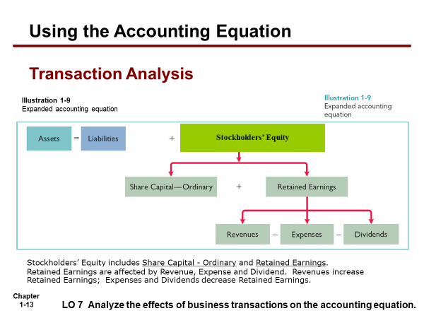

*Note: For intensive accounting, we focus on how to do the accounting record for single proprietorship; while the course Act1600 and Act 1601, we focus on how to do the accounting record for corporation.*

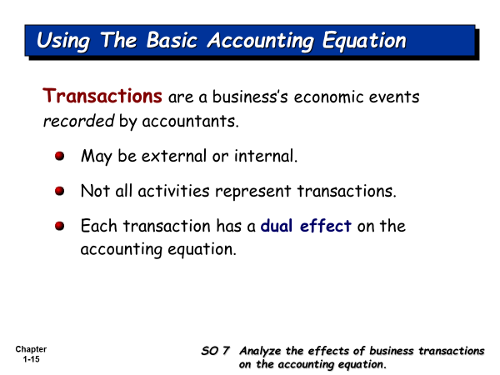

Do you know to record life transactions for yourself?

You are the entity who is separated from your mother.

**Accounting equation for your personal life. Example her shows how to apply recording everyday life transactions.**

**Assets = Claims of creditors (Liability) + Parent’s Claim**

Cash + Book + Calculator = Supplier’s Claim + Friend’s Claim + Mother Capital

+1,000 = +1,000

- 800 + 800 .

**Bal. 200 + 800 = +1,000**

- 200 + 1,000 = + 800 .

**Bal -0- + 800 + 1,000 = + 800 +1,000**

+500 = +500 .

**Bal +500 + 800 + 1,000 = +800 +500 +1,000**

- 400 = - 400 ())

-100 = - 100 (food exp)

**Bal -0- + 800 + 1,000 = +800 +500 +500**

+2,000 = +2,000

**Bal +2,000 + 800 + 1,000 = +800 +500 +2,500**

- 800 = - 800

- 500 = -500 .

**Bal +700 + 800 + 1,000 = -0- -0- +2,500**

Assets are the resources which you own.

Creditors’ claim and Parent’s claim are the sources of your resources.